**Ideation Phase**

**Define the Problem Statements**

|  |  |
| --- | --- |
| Date | 31 January 2025 |
| Team ID | LTVIP2025TMID52463 |
| Project Name | DocSpot: Seamless Appointment Booking for Health |
| Maximum Marks | 2 Marks |

**Customer Problem Statement Template:**

Create a problem statement to understand your customer's point of view. The Customer Problem Statement template helps you focus on what matters to create experiences people will love.

A well-articulated customer problem statement allows you and your team to find the ideal solution for the challenges your customers face. Throughout the process, you’ll also be able to empathize with your customers, which helps you better understand how they perceive your product or service.

Reference: <https://miro.com/templates/customer-problem-statement/>

**Example:**

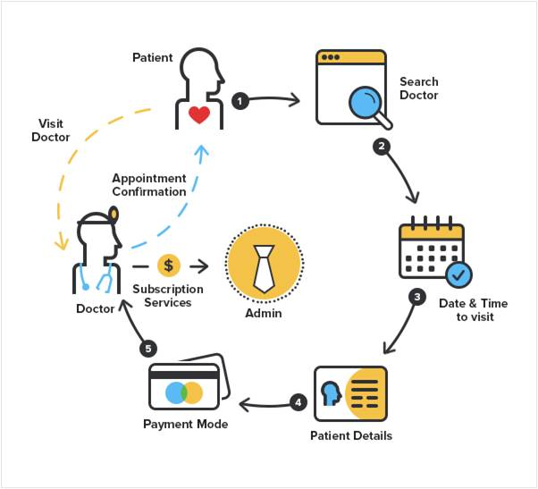

|  |  |  |  |  |  |
| --- | --- | --- | --- | --- | --- |
| **Problem Statement (PS)** | **I am (Customer)** | **I’m trying to** | **But** | **Because** | **Which makes me feel** |
| PS-1 | a busy professional/patient | book a doctor's appointment quickly and efficiently | I have to call the clinic, wait on hold, or physically visit to book an appointment | I have to call the clinic, wait on hold, or physically visit to book an appointment | frustrated, stressed, and discouraged from seeking timely medical care |
| PS-2 | a person managing healthcare for my family | schedule appointments for multiple family members | it’s hard to keep track of availability and preferences | the current system is fragmented and not centralized | overwhelmed and worried about missing appointments |